plot

Kamila Bukirova

6/4/2020

## R Markdown

I want to create different types of plots for my data based on the nature of variables. For this I am using the book by K. Healy(2019). Firstly, I will use the data from SPSS, stratified in python.

## re-encoding from UTF-8

## follow_up_2 hnc_exit_stat2  
## Min. : 4 Censor :1494   
## 1st Qu.:3904 confirmed cancer : 506   
## Median :4609 Last Participant Contact" : 18   
## Mean :4168 Death : 10   
## 3rd Qu.:5050 no time at risk : 0   
## Max. :5885 confirmed in situ/borderline/LMP/Non-targetCancer: 0   
## (Other) : 0   
## hnc_exitage hnc_exitdays   
## Min. :55.00 Min. : 15   
## 1st Qu.:69.00 1st Qu.:3909   
## Median :74.00 Median :4619   
## Mean :73.85 Mean :4178   
## 3rd Qu.:78.00 3rd Qu.:5064   
## Max. :89.00 Max. :5898   
##   
## educat   
## some college :445   
## 12 years or completed high school :431   
## College Graduate" :359   
## postgraduate :325   
## Post High School Training Other Than College":294   
## (Other) :173   
## NA's : 1   
## marital occupat pipe   
## Married Or Living As Married:1502 retired :920 never :1602   
## widowed : 166 working :821 current pipe smoker: 23   
## divorced : 269 homemaker:147 Former Pipe Smoker : 401   
## separated : 21 disabled : 62 NA's : 2   
## never married : 70 other : 45   
## (Other) : 26   
## NA's : 7   
## cigar sisters brothers asp   
## Never :1646 ONE :641 one :622 no :1023   
## Current Cigar Smoker: 43 none :500 none :481 yes : 999   
## Former Cigar Smoker : 335 TWO :387 two :411 NA's: 6   
## NA's : 4 THREE :213 three :250   
## FOUR :129 four :126   
## (Other):154 (Other):135   
## NA's : 4 NA's : 3   
## ibup asppd ibuppd hyperten_f hearta_f   
## no :1469 none :973 none :1429 no :1373 no :1818   
## yes : 557 1/Day :438 2+/day : 131 yes : 652 yes : 207   
## NA's: 2 3-4/week:180 3-4/week : 127 NA's: 3 NA's: 3   
## <2/month:135 <2/month : 109   
## 2+/day :122 2-3/month: 94   
## (Other) :177 (Other) : 136   
## NA's : 3 NA's : 2   
## stroke_f emphys_f bronchit_f diabetes_f polyps_f arthrit_f   
## no :1969 no :1947 no :1908 no :1881 no :1840 no :1267   
## yes : 56 yes : 78 yes : 117 yes : 143 yes : 184 yes : 759   
## NA's: 3 NA's: 3 NA's: 3 NA's: 4 NA's: 4 NA's: 2   
##   
##   
##   
##   
## osteopor_f divertic_f gallblad_f bq_age race7   
## no :1944 no :1887 no :1802 Min. :54.00 white, non-hispanic:1812   
## yes : 75 yes : 135 yes : 222 1st Qu.:58.00 black, non-hispanic: 93   
## NA's: 9 NA's: 6 NA's: 4 Median :62.00 hispanic : 37   
## Mean :62.41 asian : 67   
## 3rd Qu.:66.00 pacific Islander : 10   
## Max. :75.00 American Indian : 8   
## missing : 1   
## smoked_f smokea_f rsmoker_f ssmokea_f cigpd_f   
## no : 101 Min. : 8.00 no :1522 Min. : 0.00 11-20 :708   
## yes:1927 1st Qu.:16.00 yes : 405 1st Qu.:27.00 1-10 :427   
## Median :17.00 NA's: 101 Median :40.00 21-30 :404   
## Mean :18.09 Mean :36.56 31-40 :243   
## 3rd Qu.:19.00 3rd Qu.:51.00 41-60 :117   
## Max. :71.00 Max. :72.00 (Other):128   
## NA's :107 NA's :279 NA's : 1   
## filtered_f cig_stat cig_stop   
## filter :1415 never smoked cigarettes : 101 Min. : 0.00   
## non-filter : 348 current cigarette smoker: 405 1st Qu.: 1.00   
## about equal: 161 former cigarette smoker :1522 Median :13.00   
## NA's : 104 Mean :15.26   
## 3rd Qu.:26.00   
## Max. :54.00   
## NA's :108   
## cig_years pack_years bmi_curc state   
## Min. : 0.50 Min. : 0.25 0-18.49 : 14 minnesota :264   
## 1st Qu.:18.00 1st Qu.: 16.50 18.5-24.999:644 pennsylvania:230   
## Median :30.00 Median : 33.00 25-29.999 :895 michigan :209   
## Mean :28.73 Mean : 38.80 30+ :444 wisconsin :181   
## 3rd Qu.:40.00 3rd Qu.: 52.50 NA's : 31 missouri :140   
## Max. :60.00 Max. :255.00 (Other) :994   
## NA's :137 NA's :140 NA's : 10   
## bmi_20c bmi_50c colon_comorbidity liver_comorbidity  
## 0-18.49 : 156 0-18.49 : 19 no :1998 no :1925   
## 18.5-24.999:1523 18.5-24.999:950 yes : 23 yes : 96   
## 25-29.999 : 289 25-29.999 :781 NA's: 7 NA's: 7   
## 30+ : 28 30+ :245   
## NA's : 32 NA's : 33   
##   
##   
## fh_cancer hnc_fh_cnt hnc_fh   
## no : 868 Min. :0.0000 no :1930   
## yes :1159 1st Qu.:0.0000 yes, immediate family member : 32   
## NA's: 1 Median :0.0000 possibly-relative or cancer type not clear: 63   
## Mean :0.0158 NA's : 3   
## 3rd Qu.:0.0000   
## Max. :2.0000   
## NA's :3   
## is_dead_with_cod is_dead mortality_exitage  
## not confirmed dead:1363 not confirmed dead:1363 Min. :60.00   
## dead : 664 dead : 663 1st Qu.:75.00   
## NA's : 1 NA's : 2 Median :79.00   
## Mean :79.08   
## 3rd Qu.:84.00   
## Max. :95.00   
## NA's :1   
## mortality_exitstat mortality_exitdays ph_any_bq   
## death : 664 Min. : 436 no :1947   
## last NDI/Cutoff:1106 1st Qu.:5518 yes : 81   
## refusal : 244 Median :6439 unknown: 0   
## other : 13 Mean :6087   
## NA's : 1 3rd Qu.:7150   
## Max. :8077   
## NA's :1   
## center arm sex   
## university of minnesota :383 intervention:1034 male :1279   
## henry ford health system :302 control : 994 female: 749   
## university of pittsburgh :241   
## washington university in st louis :236   
## university of colorado :222   
## marschfield clinic research foundation:206   
## (Other) :438   
## agelevel rndyear_cat   
## <=59 :656 1993-1995: 599   
## 60-64:681 1996-1998:1148   
## 65-69:470 1999-2001: 281   
## >=70 :221   
##   
##   
##   
## educ_new_cat  
## less than 11 years :173   
## 12 years or completed high school :431   
## post high school training other than college:294   
## some college :445   
## college graduate :359   
## postgraduate :325   
## NA's : 1   
## marital_Recoded race_recoded   
## married or living as married:1502 white, non-hispanic:1812   
## widowed : 166 black, non-hispanic: 93   
## divorced or separated : 290 hispanic : 37   
## never married : 70 asian : 67   
## other : 19   
##   
##   
## state_recoded bmi_difference_recoded difference_age   
## foreign country : 97 negative difference: 49 Min. : 0.000   
## northeast : 351 no difference :1942 1st Qu.: 3.000   
## midwest :1084 1-2 difference : 0 Median : 6.000   
## south : 183 3 difference : 2 Mean : 5.228   
## west : 282 NA's : 35 3rd Qu.: 6.000   
## u.s. territories: 0 Max. :19.000   
## NA's : 31 NA's :1   
## difference_age_cat bmi_difference_cat_50_cur_recoded  
## difference of 0 : 67 negative difference: 111   
## <5 years difference: 614 no difference :1298   
## >=5 years :1346 1-2 difference : 584   
## NA's : 1 3 difference : 6   
## NA's : 29   
##   
##   
## hnc_exit_stat_new Rfollow_ follow_up_norm   
## negative hnc:1522 Min. :0.0004931 Min. :-3.294436   
## positive hnc: 506 1st Qu.:0.2503698 1st Qu.:-0.673714   
## Median :0.4992604 Median :-0.001854   
## Mean :0.5002465 Mean :-0.000002   
## 3rd Qu.:0.7507396 3rd Qu.: 0.674104   
## Max. :1.0000000 Max. : 3.294436   
## NA's :1   
## RFR001 hnc_exitdays_norm Rsmokea_ smokea_f_norm   
## Min. :0.0004931 Min. :-3.294436 Min. :0.00078 Min. :-3.16297   
## 1st Qu.:0.2502465 1st Qu.:-0.673714 1st Qu.:0.30036 1st Qu.:-0.52335   
## Median :0.5007396 Median : 0.001854 Median :0.43883 Median :-0.15393   
## Mean :0.5002465 Mean :-0.000006 Mean :0.50026 Mean : 0.00121   
## 3rd Qu.:0.7507396 3rd Qu.: 0.674879 3rd Qu.:0.71629 3rd Qu.: 0.57187   
## Max. :1.0000000 Max. : 3.294436 Max. :1.00000 Max. : 3.27917   
## NA's :1 NA's :107 NA's :108   
## Rssmokea ssmokea_f_norm Rcig_sto cig_stop_norm   
## Min. :0.07433 Min. :-1.44429 Min. :0.1122 Min. :-1.21470   
## 1st Qu.:0.25071 1st Qu.:-0.67224 1st Qu.:0.2466 1st Qu.:-0.68518   
## Median :0.49171 Median :-0.02078 Median :0.5013 Median : 0.00326   
## Mean :0.50029 Mean : 0.01625 Mean :0.5003 Mean : 0.02619   
## 3rd Qu.:0.75672 3rd Qu.: 0.69578 3rd Qu.:0.7422 3rd Qu.: 0.65010   
## Max. :1.00000 Max. : 3.13556 Max. :1.0000 Max. : 3.27902   
## NA's :279 NA's :280 NA's :108 NA's :109   
## Rcig_yea norm_cig_years Rpack_ye pack_years_norm   
## Min. :0.00106 Min. :-3.07355 Min. :0.00053 Min. :-3.27428   
## 1st Qu.:0.25568 1st Qu.:-0.65671 1st Qu.:0.25238 1st Qu.:-0.66701   
## Median :0.48810 Median :-0.02983 Median :0.50477 Median : 0.01195   
## Mean :0.50026 Mean : 0.00018 Mean :0.50026 Mean : 0.00039   
## 3rd Qu.:0.74960 3rd Qu.: 0.67324 3rd Qu.:0.75132 3rd Qu.: 0.67866   
## Max. :1.00000 Max. : 3.27473 Max. :1.00000 Max. : 3.27428   
## NA's :137 NA's :138 NA's :140 NA's :141   
## mortality_age_norm RFR002 Rmortali   
## Min. :-3.178573 Min. :0.00074 Min. :0.0004933   
## 1st Qu.:-0.628993 1st Qu.:0.26468 1st Qu.:0.2503700   
## Median : 0.005565 Median :0.50222 Median :0.4997533   
## Mean : 0.001640 Mean :0.50025 Mean :0.5002467   
## 3rd Qu.: 0.743257 3rd Qu.:0.77134 3rd Qu.:0.7501233   
## Max. : 3.178573 Max. :0.99926 Max. :1.0000000   
## NA's :1 NA's :1 NA's :1   
## mortality_exitdays_norm bmi_20 bmi_50 bmi_curr   
## Min. :-3.294298 Min. :15.21 Min. :16.82 Min. :15.62   
## 1st Qu.:-0.673714 1st Qu.:20.08 1st Qu.:23.01 1st Qu.:24.02   
## Median :-0.000618 Median :21.70 Median :25.06 Median :26.58   
## Mean :-0.000002 Mean :22.12 Mean :25.63 Mean :27.18   
## 3rd Qu.: 0.673714 3rd Qu.:23.73 3rd Qu.:27.43 3rd Qu.:29.41   
## Max. : 3.294298 Max. :47.23 Max. :47.84 Max. :58.58   
## NA's :2 NA's :32 NA's :33 NA's :31

##Just to try ## Including Plots

I will take two numeric variables from my data and will construct the geom_point for looking at the relation between the cigarette years and hnc exitage

## Warning: package 'tidyverse' was built under R version 3.6.3

## -- Attaching packages ------------------------------------------------------------------------------------------- tidyverse 1.3.0 --

## v ggplot2 3.3.0 v purrr 0.3.4  
## v tibble 3.0.1 v dplyr 1.0.0  
## v tidyr 1.0.2 v stringr 1.4.0  
## v readr 1.3.1 v forcats 0.5.0

## Warning: package 'ggplot2' was built under R version 3.6.3

## Warning: package 'tibble' was built under R version 3.6.3

## Warning: package 'tidyr' was built under R version 3.6.3

## Warning: package 'readr' was built under R version 3.6.3

## Warning: package 'purrr' was built under R version 3.6.3

## Warning: package 'dplyr' was built under R version 3.6.3

## Warning: package 'stringr' was built under R version 3.6.3

## Warning: package 'forcats' was built under R version 3.6.3

## -- Conflicts ---------------------------------------------------------------------------------------------- tidyverse_conflicts() --  
## x dplyr::filter() masks stats::filter()  
## x dplyr::lag() masks stats::lag()

## Warning: Removed 141 rows containing missing values (geom_point).

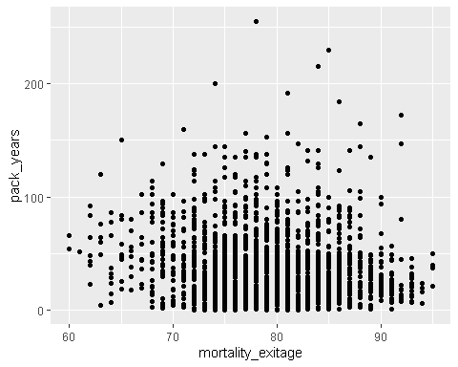 and normalized graph alongside.

## Warning: Removed 142 rows containing missing values (geom_point).

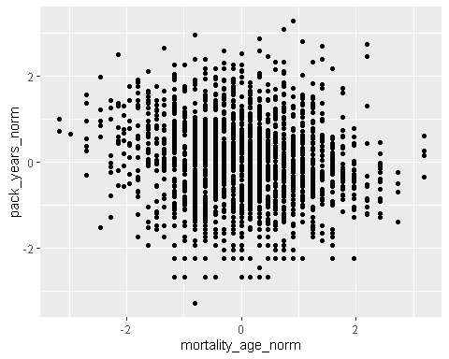 We did the same for the age of start smoking and age of the hnc was firstly diagnosed

## Warning: Removed 107 rows containing missing values (geom_point).

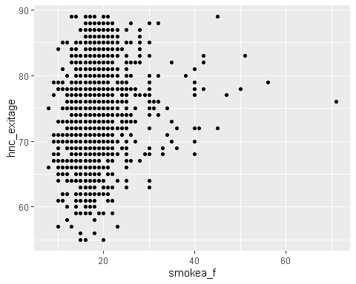

and normalized one

## Warning: Removed 108 rows containing missing values (geom_point).

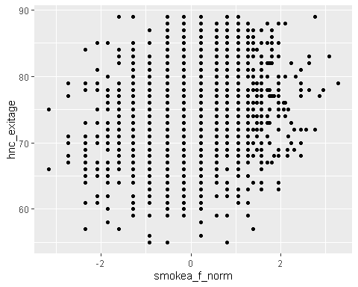 I want to take a look at the missingness pattern

## Warning: package 'naniar' was built under R version 3.6.3

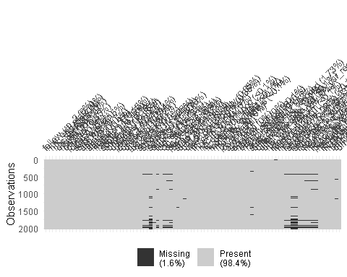

and at the missingness patterns for the data prepared for imputation

## [1] 68

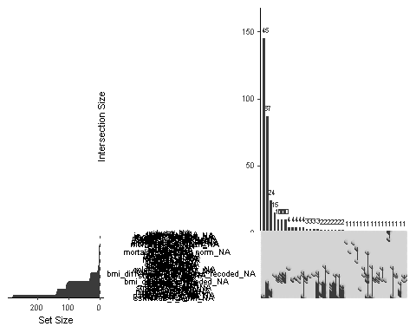 and for just 10 variables in a row 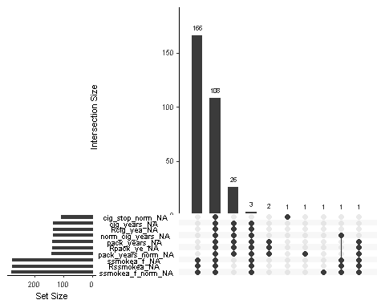

I want to check the missingness in variables

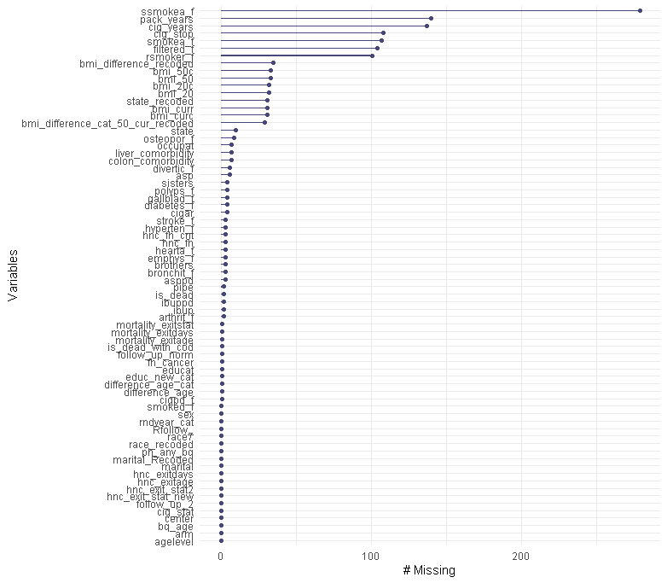

The variable with the most missing values is “At what age did you last stop smoking cigarettes regularly?” (13.8%) and “Number of packs smoked per day*years smoked” and “The total number of years the participant smoked” (6.9 and 6.8% respectively); and “#of years since stopped smoking cigarettes”, “At what age did you start smoking cigarettes regularly”, “During periods of smokinmg, did or do you more often smoke filter or non-filter cigarettes?”, “Do you smoke cigarettes regularly now?”. Thus, mostly, people avoided to answer the smoking-related question *(5.9 and 5.8% respectively).

The missing chart shows us that even though we have the concentration of the missingness in the upper left and the lower right corners, we still have islands of missing values across the variables, so there is no monotonicity.

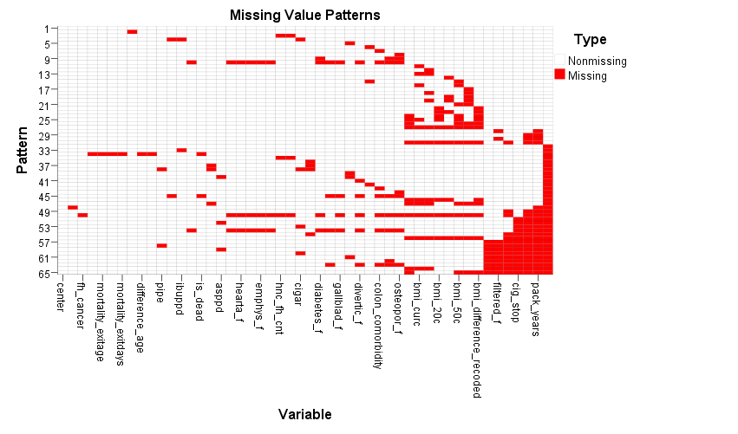

More than 80% of the data follows the pattern 1 what indicates there are no missing values across al variables, around 10% of the data follow the pattern 32 with the missing values on BMI variables and smoking-related variables.

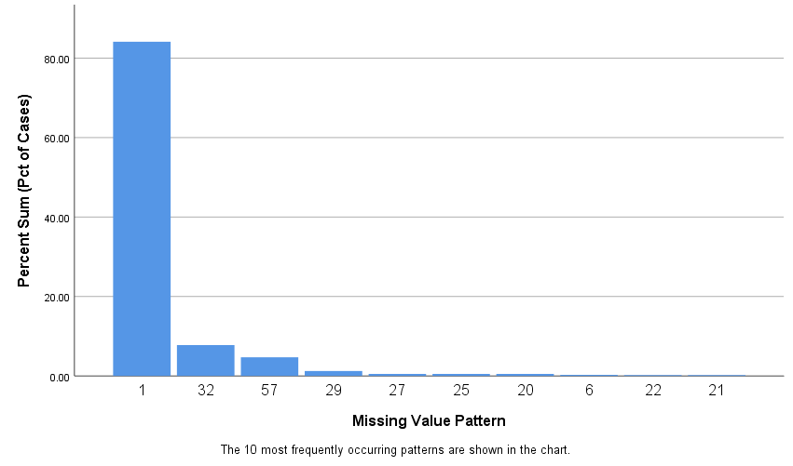

So; we have a missing data at random (MAR),

The multiple imputation procedeure did not run due to the excess of parameters, thus we have to combine some of the categories for certain categorical variables:

e.g., we combined the categories “homemaker” and “unemployed” into one, and the we also combined “extended sick leave” and “disabled”, so the occupation variable was recoded and got 5 states instead of 7.

We changed the states of the sister and brothers variables: combining 1-3 sisters (brothers) into the first category, 4-6sisters (brothers) into the second, and 7 and more into the third, additionally we had 0 category for “no sisters (brothers)”.

We combined aspirin and ibuprofen per day intake from 7 categories to 5 based on the their frequency and common sense. The further recoding was impossible to carry out.

Based on our analysis all the numerical variables are non-normally distributed (Kolmogorov-Smirnov tests: p<0.05). Thus, we must have normalized the numerical variables first (overall 16 variables). The normalization process was performed in two steps: initially, we applied the fractional rank and then used the inverse normal transformation, so-called rank-based inverse normal transformation procedure.